Chapter 8, Solution 47.

Find the output voltage v_{o}(t) in the circuit of Fig. 8.94.

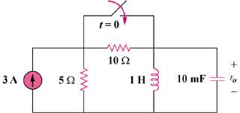

Figure 8.94
For Prob. 8.47.

Solution
At t = 0-, we obtain, i_{L}(0) = 3x5/(10 + 5) = 1A

and v_{o}(0) = 0.

For t > 0, the 10-ohm resistor is short-circuited and we have a parallel RLC circuit with a step input.

- = 1/(2RC) = (1)/(2x5x0.01) = 10

ω_{o} = 1/ = 1/ = 10

Since α = ω_{o}, we have a critically damped response.

s_{1,2} = -10

Thus, i(t) = I_{s} + [(A + Bt)e^{-10t}], I_{s} = 3

i(0) = 1 = 3 + A or A = -2

v_{o} = Ldi/dt = [Be^{-10t}] + [-10(A + Bt)e^{-10t}]

v_{o}(0) = 0 = B – 10A or B = -20

Thus, v_{o}(t) = (200te^{-10t}) V

